4K Byte-Sector HDD-Data Format Standard
Martin Hassner, Hitachi Global Storage Technologies, and Ed Grochowski, Storage Consultant
San Jose CA 95120
July 31, 2026

Abstract
This paper provides information about the motivation behind the 4096 byte-Sector HDD-data format and its potential impact on the HDD and IT Industries.
The main motivation is to maintain HDD data integrity while continuing to increase areal density. At the current format 512-byte sector format, these requirements are becoming incompatible, as the increased bit error rate due to additional error check overhead is offsetting the effect of additional correction capability.
It is well known in coding/communication theory that the efficiency of error correction codes increases with the size of the code length. Thus the same percentage of overhead for a long block is much more efficient than in a short block, as the number of combinations of correctable error patterns is dependent on the length of the coded block of data.
In this paper we analyze the performance and gains of long block error correction, as well as describe a practical Hard Disk controller implementation that will provide a smooth transition for the IT Industry, provided the OS permits aligned 4K-sector writes.

Contents

Abstract……………………………………………………………………………………..1
Introduction……………………………………………………………………………….. .2

Figures………………………………………………………………………………………3

IDEMA Committee………………………………………………………………………….4

Conclusion and Acknowedgement…………………………………………………………………………. 5

Appendix…………………………………………………………………………………….6

Introduction
This paper provides information relating to a new hard disk drive standard, 4096 byte sectors, to replace the existing 512 byte sector standard which has existed for over 25 years.
This paper reports on the recommendations of an IDEMA (International Disk Drive Equipment and Materials Associations) sponsored committee with membership from a majority of hard disk drive producers.
Chronology;
- IBM Taskforce Recommendation (M. Hassner)
- NSIC White Paper (D. Cheng, M. Hassner, B.Lamberts, R. Wood, IBM )
2000 TMRC ISF Presentation (M. Hassner)
2000 IDEMA Long Data Block Committee (E. Grochowski, M. Hassner)
2003 Seagate/Maxtor/Fujitsu/Hitachi GST Joint 4K Sector Position Letter to
Microsoft
- 4K Sector support Letter from Microsoft on Longhorn OS
- 4K BIOS Support Position from Phoenix
- Estimated 4K sector HDD’s available
Why a New Standard?
Areal densities (data densities) in HDD’s are increasing on a yearly basis, and this involves a continuous loss of SNR. Data integrity, or sector failure rate, must be maintained to meet user requirements, and this cannot be accomplished by adding more ECC (error correction bytes) at the current 512 byte format. This bottleneck has been recognized by all major HDD producers. Furthermore, areal density increases involve an increased sensitivity to defects which cannot be corrected at the current sector format.
Current HDD products use approximately 9% of ECC overhead to correct a raw bit error rate from 10⁻⁵ to 10⁻¹¹. Future HDD product specifications assume a linear density at which the raw bit error rate is 10⁻³. Such a raw bit error rate cannot be corrected at the current 512 byte sector format, independently of the number of ECC bytes. Anticipated defect sizes of approximately 100 bytes cannot be corrected at this sector format.
Using the same amount of ECC overhead, 9%, at 4K sector format, a raw bit error rate of 10^{-2.4} can be corrected to the required 10⁻¹¹ target, solving the bottleneck problem. In addition, a 4k sector format ECC allows the correction of defect sizes of up to 400 bytes.
Disk defects and processing damage comprise a majority of HDD field failures, and as areal density increases the smaller bit sizes effectively increase defects density. Lower flying height within the drive also increases defect sensitivity.
It is important to note that HDD industry trends include an increase in areal density as user requirements require. This results in the obvious capacity increase per drive as well as faster performance and reduced price per Gigabyte, all important to HDD users. It is expected that this trend will continue throughout this decade.

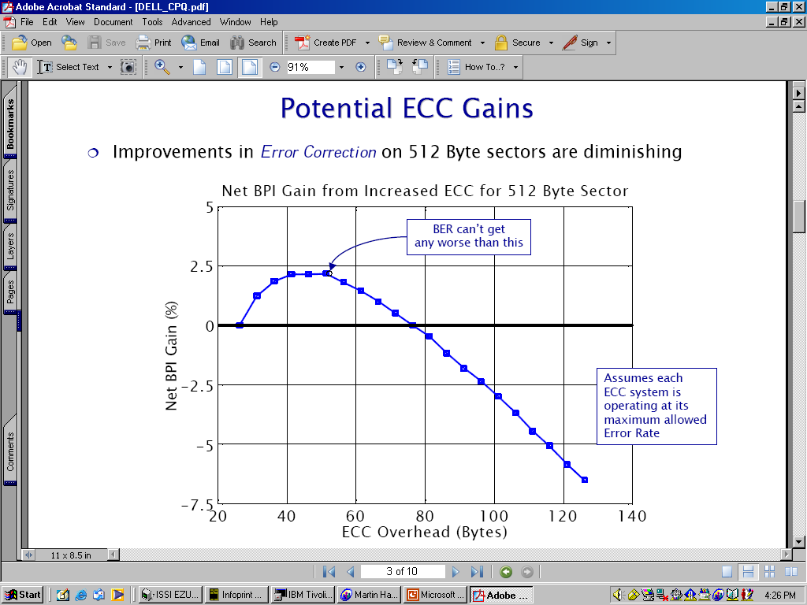

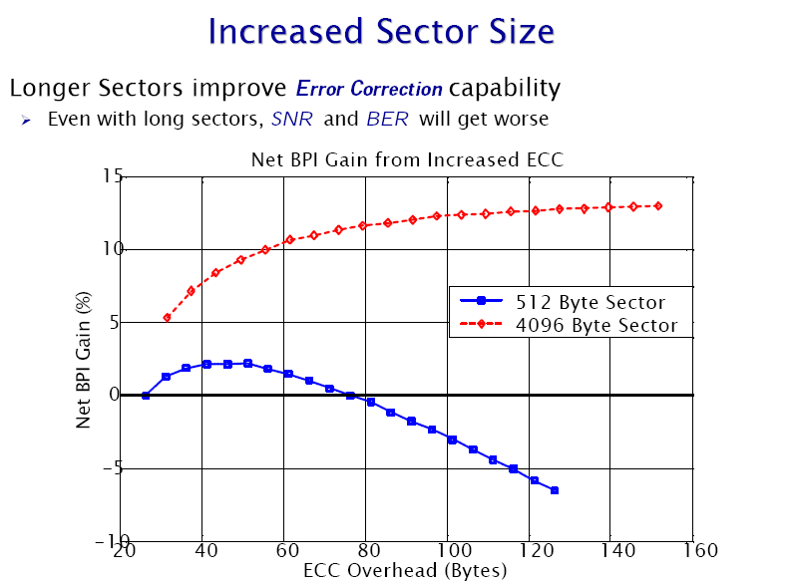

IDEMA Committee
One of the principal missions of IDEMA is to generate and refine HDD standards which will enhance the capacity, performance, reliability and manufacturability of this key IT product technology. Recognizing the inadequacy of the current 512 byte sector standard as areal density increases, IDEMA sponsored a committee to address defining a new standard for future HDD’s and investigate how this standard could be implemented. This Committee consisted of all major disk drive producers, or those who chose to remain aware of the Committee’s progress by remaining on copy of all documents. The active participants represented Seagate, Maxtor, Fujitsu, Hitachi GST and those who were on copy represented the remainder of the world’s HDD producers. In addition, Committee participants included OS, BIOS, electronics and software developers.
The Committee elected to recommend 4096 bytes as the optimum sector size standard, smaller sectors offered little advantage and larger than 4K byte sectors would not be necessary at this time. Each member HDD producers drafted a support position document which concurred with 4K bytes as industry standard as a direction for the IT world to pursue. This IDEMA Committee next contacted OS producers including the Microsoft Corporation with these findings, and this resulted in Microsoft including a 4K byte sector capability in the next generation Windows OS. At Microsoft’s request the Committee worked with a BIOS developer, Phoenix, to begin writing specifications for booting a native 4K byte drive. Other electronics developers supporting the HDD industry have been contacted.
The Committee notified IEEE Committees for both SCSI and ATA interfaces and each will include 4K byte sectors standards information in any new specifications documents that are written and published.
Implementation of 4K Byte Sector Drives
During the time when initial 4K drives become available, the industry will see both 4K and 512 byte sector products in the market. Newer systems should begin to use the 4K standard HDD’s as soon as possible since both drives, OS and BIOS will be available and a higher capacity, faster and more reliable drive will enhance the system. It is expected that there will be a rapid migration to these products.
The case of systems upgrades, in which a user with a legacy OS will replace a existing 512 byte drive with a newer and higher capacity drive presents several possible for solution and use. It was decided that each disk drive producer would decide how best to meet this requirement and the Committee would not address this issue. An obvious solution would be to provide 512 byte drives for system upgrades until the demand stops. Another would be to provide an upgrade kit with each 4K byte drive which would allow legacy OS users the opportunity to realize the advantages of 4K byte drives with minimal changes. There are several other potential directions which HDD producers could elect to pursue.

Conclusion
The requirement for a larger sector size is driven by the HDD industry. The IDEMA Committee has proven that 4K byte sectors will enhance HDD format efficiency by minimizing the additional disk space required for ECC fields at higher areal densities. 4K byte sectors reduce the number of overhead fields and allow more room for magnetic heads and media as well as signal processing electronics to improve in capacity and performances. 4K sectored drives have the capability of increased defect correction with better format efficiency.
OS developers as Microsoft and BIOS developers as Phoenix are involved in supporting 4K sectored HDD and first products could be available in 2006. Users of HDD products, including SCSI and ATA interfaces as well as their follow-ons, are now required to anticipate the use of 4K sector drives and implement any modifications in their products, as appropriate, to realize the advantages of capacity, performance and reliability that this new HDD standards provides.
Acknowledgement
The authors wish to acknowledge the support of Steve McCarthy, previously of the Maxtor Corporation, and a member of the IDEMA 4K Committee for providing assistance in the Figures.

